**DAILY ONLINE ACTIVITIES SUMMARY**

|  |  |  |  |  |  |  |  |
| --- | --- | --- | --- | --- | --- | --- | --- |
| **Date:** | **30/05/2020** | | | | **Name:** | **Amrutha g** | |
| **Sem & Sec** | **4TH&A** | | | | **USN:** | **4AL18CS006** | |
| **Online Test Summary** | | | | | | | |
| **Subject** | | **1.DATA COMMUNICATION**  **2.COMPLEX ANALYSIS,PROBABILITY AND STASTICAL METHOD** | | | | | |
| **Max. Marks** | | **30**  **30** | | **Score** | | **27**  **29** | |
| **Certification Course Summary** | | | | | | | |
| **Course** | **Marketing foundations**  **Cloud foundations** | | | | | | |
| **Certificate Provider** | | | **GREATLEARNING** | **Duration** | | | **2.25 hours**  **5 hours** |
| **Coding Challenges** | | | | | | | |
| **Problem Statement:1:** **Write a C Program to count Uppercase, Lowercase, special character and numeric values for a given string.** | | | | | | | |
| **Status: executed** | | | | | | | |
| **Uploaded the report in Github** | | | | **YES** | | | |
| **If yes Repository name** | | | | **https://github.com/AMRUTHAGANESH/lockdown-codings** | | | |
| **Uploaded the report in slack** | | | | **YES** | | | |

Online Test Summary 1: 18CS46 online test was scheduled from 9:15 am to 10:00am. The portion for the IA was 3rd and 4th module. The score I received was 27/30. 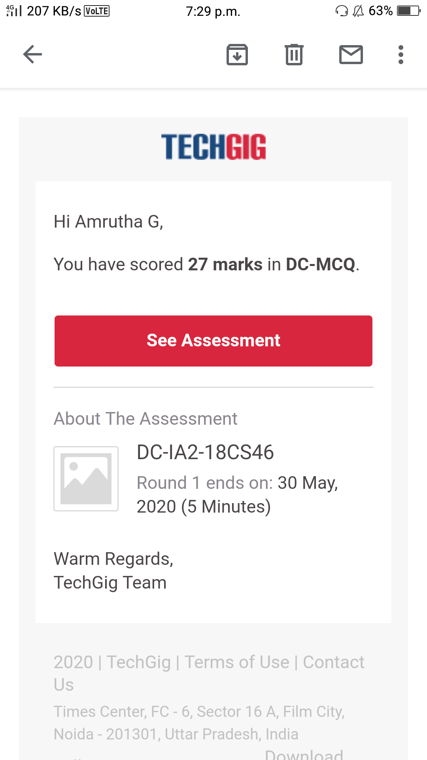

Online Test Summary 2: 18MAT41 online test was scheduled from 3:00am to 3:40 am. The portion for the IA was 3rd module. The question were MCQ type There were 30 question 1 mark respectively duration is 40 minutes .The score I received was 29/30.

**Online Certification course:**

Name of the course :- marketing foundation

Today I finished my certification course and also I got a certificate of marketing foundation

Snap shot :



Today I started a new certification course

Name of the course : cloud foundation

Duration:5 hours

Certificate provider: great learning academy

This the snapshot of the new course:



Online Coding summary:

1. **:** **Write a C Program to count Uppercase, Lowercase, special character and numeric values for a given string.**

